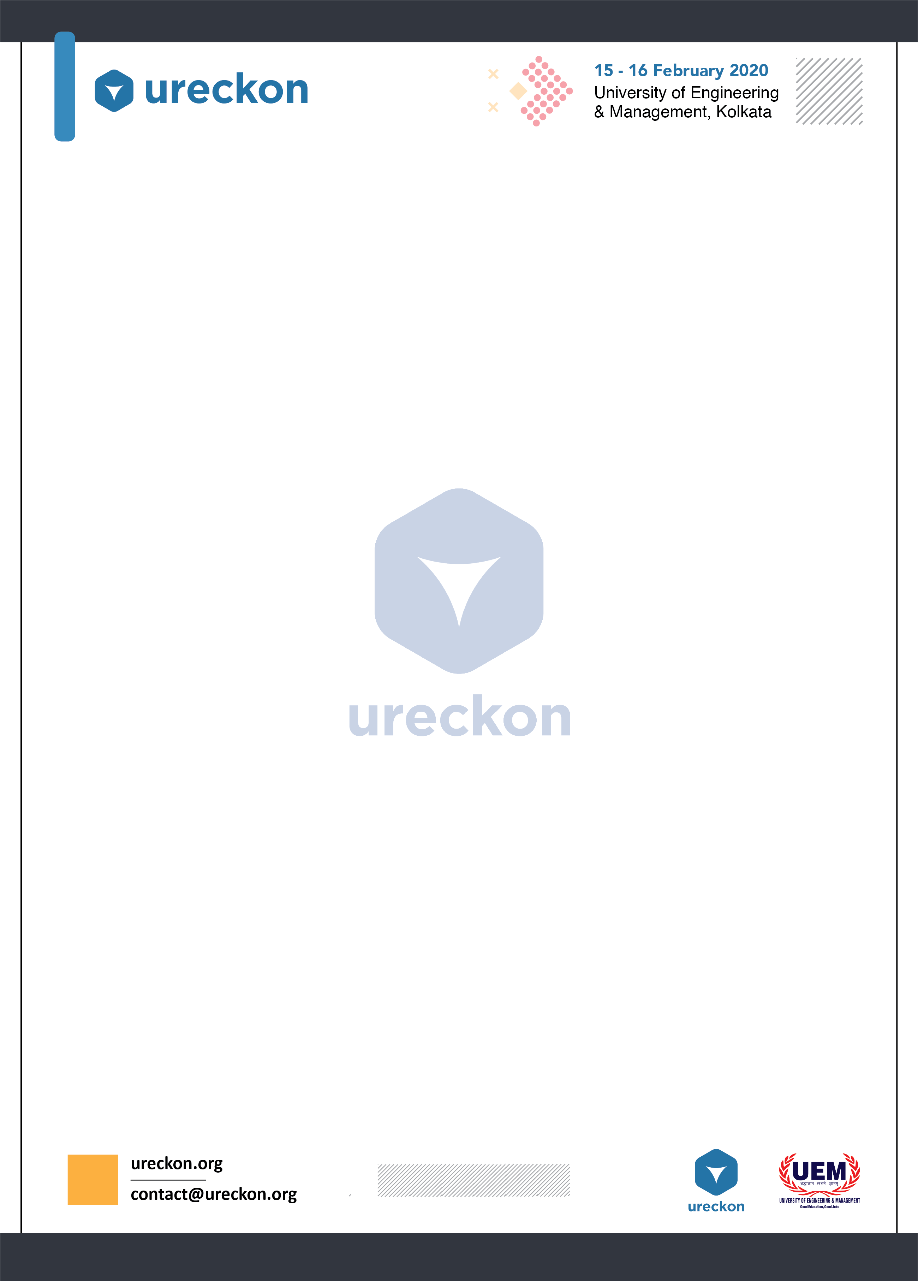

**TOM CLANCY’S RAINBOW SIX SIEGE**

**GAME MODE: TEAM DEATH MATCH – BOMB (PRO LEAGUE FORMAT)**

**ABOUT THE TOURNAMENT:**

* It is a 5 v 5 Squad based tournament.
* Team will be disqualified if 5 members are not present during match time.
* Duration – 45 minutes per match (Including Setup time).
* Standard ESL MAP POOL:
* Bank
* Border
* Club House
* Coastline
* Consulate
* Villa
* Kafe Dostoyevsky
* Operators Not Allowed:
* Kali
* Wamai
* Format: B01 for all matches.

**GAME RULES:**

* Only a *LIMITED NUMBER OF REGISTRATIONS* allowed due to tier structure of the tournament, 8 to be precise.
* Registration is confirmed only after final payment at the registrations desk on the day of the tournament and the team that makes payment will be allocated matches on a *FIRST COME FIRST SERVE BASIS.*
* After limited teams are filled, no other registrations or payments will be allowed.
* Solo registrations will only be allowed if a team member cannot show up with prior valid notifications.
* Any payment made at the registrations desk is *NON-REFUNDABLE*.



* If your squad has been allocated a slot for the match and you fail to arrive before the deadline time, your team will be striked off the list.
* If a Player is Disconnected or glitches within the 1st 15 seconds of action phase or is unable to rejoin, then only the in game leaders may call for a rehost.
* No *ABUSIVE BEHAVIOUR* will be tolerated or entertained in the college premises and will lead to *DIRECT DISQUALIFICATION.*
* Any Decision made by the admins is *FINAL AND NOT NEGOTIABLE.*

**BRACKETS WILL BE FORMED ON SPOT VIA A RANDOM TOURNAMENT GENERATOR. IF YOU WANT A SAFE SPOT IN THE TABLE, REGISTER EARLY.**

**COORDINATOR LIST FOR QUERIES:**

RICHIK GANGOPADHYAY

+91 96743 77482

SOHAM HALDER

+91 80133 085508